**Bernhardt Loft Piper Round Mirror in Brushed White**

**Price: $470**

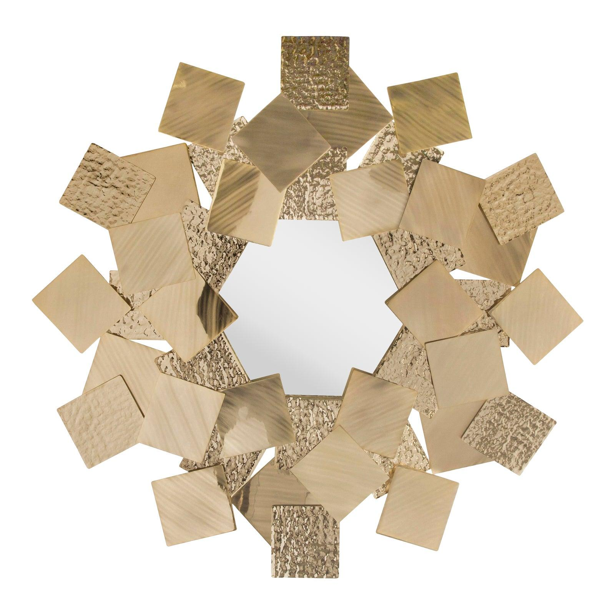

* CATEGORIES

Dressing Room

* MATERIALS

Decorative Mirrors

* SHAPE

Circle

* BRAND

Inax